Task 1

Subject

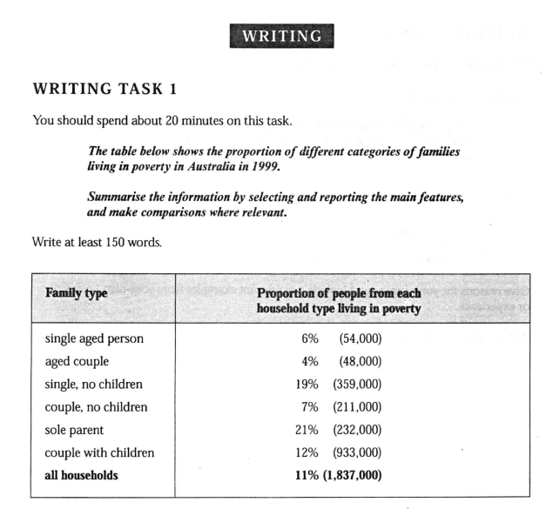

1, First edition

**Don’t write any of your opinion!!**

Analysis of Families Type in Poverty

The proportion of all household types living in poverty is 11%. ~~It is a serious problem.~~ What is worse is that nearly one-fifth of sole parents are living in poverty. ~~Many children might not be well raised because their parents could not earn enough money to support their families~~. Let’s see the families of couples with children; the percentage is 12% and it is higher than the average rate, but the proportion is 7% for couples without children. ~~That means raising children costs much money and is quite difficult for couples, let alone a sole parent.~~

The weird thing is that 19% of single persons also live in poverty so it is a right choice for them to choose to be unmarried, or their children won’t have access to nutritious meals.

There is a small proportion among aged and single aged couples. They are old and should live a happy retired life.

**2. Improment from me.**

***The second version by me***

The table gives us information of different types of family who were living in poverty in Australia in 1999.

Among the family which consists of an old people or old couple, those in poverty only account for 4 and 6 percent respectively. There is 7 percent of couples who have no child still live in poverty. 19 percent of those people who neither got married nor have a child live in poverty. The percentage of single parent is 21. Couples with children who come from deprived home account for 12 percent. On average, 11 percent of total family live in poverty, which mean that over 1.8 million familly have not enough money to make ends meet.

***The third version.***

The table shows the breakdown of different types of family who were living in poverty in Australia in 1999.

In general, 11% of the family were in the condition, comprising almost two million people. Whereas, the family of single parent or one adult doubled the proportion, with 21% and 19% respectively. There were over 900 thousand of couples with children, which accout for 12% of the type of the family, who had deprived home.

On the other hand, only 7% of couples with no children were living in poverty. The percentage of family of elderly people was also lower than the average level. For aged people it is 6% and for aged couples it is 4%.

In conclusion, it is obvious that the poverty rate of family with children is higher than those who didn’t, and family of couples were less likely to live in poverty than those of single parents. There were also less poor family among older people.

**3. Improved by Grammarly**

The poverty rate among all household types is 11%, which is a severe problem. However, the situation is even worse for sole parents, with nearly one-fifth of them living in poverty. This can lead to a lack of proper upbringing for their children due to financial constraints. When it comes to couples with children, the poverty rate is 12%, which is higher than the average rate, while it is only 7% for couples without children. This indicates that raising children can be quite challenging and expensive for couples, especially for sole parents.

Interestingly, 19% of single individuals are also living in poverty, which makes it a wise choice for them to remain unmarried, as the lack of financial resources might prevent their children from having access to nutritious meals.

On the other hand, the poverty rate is relatively low for the elderly and single-aged couples, who should be able to enjoy a happy and comfortable retired life.

**4, Improved by ChatGPT with thorough explanation**

**A question asked by me:**

**“**Analyse the following essay one sentence by one and improve them and explain why you do it.**”**

"The table provides information about different types of families living in poverty in Australia in 1999."

**Explanation:** Clarified the sentence structure for better readability and removed redundancy ("gives us") to make it more concise.

"Among the families consisting of elderly individuals or couples, only 4 percent and 6 percent, respectively, are living in poverty."

**Explanation:** Revised to improve clarity and precision by specifying the percentages for each category separately and using "individuals" instead of "old people."

"Seven percent of childless couples are still living in poverty."

**Explanation:** Simplified the sentence structure and improved clarity by specifying the percentage directly after the subject.

"Nineteen percent of unmarried individuals without children are living in poverty."

**Explanation:** Replaced "those people who neither got married nor have a child" with "unmarried individuals without children" for conciseness and clarity.

"Twenty-one percent of single parents are living in poverty."

**Explanation:** Clarified the sentence structure and improved readability by specifying the percentage directly after the subject.

"Twelve percent of couples with children from disadvantaged backgrounds are living in poverty."

**Explanation:** Clarified the sentence structure and improved precision by specifying that the children come from deprived homes.

"On average, 11 percent of all families live in poverty, meaning that over 1.8 million families do not have enough money to make ends meet."

**Explanation:** Revised to improve clarity and precision by stating the average percentage of families in poverty and providing context about the number of affected families.

**5, Official demo**

WRITING TASK 1

*考官范文

The table gives a breakdown of the different types of family who were living in poverty in Australia in 1999.

On average, 11% of all households, comprising almost two million people, were in this position. However, those consisting of only one parent or a single adult had almost double this proportion of poor people, with 21% and 19% respectively.

Couples generally tended to be better off, with lower poverty levels for couples without children (7%) than those with children (12%). It is noticeable that for both types of household with children, a higher than average proportion were living in poverty at this time.

Older people were generally less likely to be poor, though once again the trend favoured elderly couples (only 4%) rather than single elderly people (6%).

Overall the table suggests that households of single adults and those with children were more likely to be living in poverty than those consisting of couples.

分析

雅思的图表作文是写作Task1的必考项目(Task2是议论文)。图表通常分为两大类:一类是数据图,包 括曲线图(graph/line chart),柱状图(bar chart/column chart),饼状图(pie chart)和表格(table);另一大类是 示意图(diagram)。目前在雅思考试中主要出现的是数据图。

对于数据图来说,首先要仔细审题。审题包括看文字说明以及图表。文字说明部分一般提供了有关这 个图表的最基本信息,如所涉及的时间、地点和研究的对象。对于图表部分,我们需要仔细考查,找出值得 描述的总体趋势(overall trends)和不规则变化(irregularities)。

图表作文通常应该分成三部分:

第一部分介绍图表基本事实性信息。我们通常可以把题目进行改写。对比题目和范文:show—give, proportion breakdown, type-category, who were living living。其实就是使用同义词替换和语法改写。

第二部分是图表作文的主体。其中最关键的是分析并描写趋势。很多考生可能会草率地直接从上往下 逐一描述,这样的结果就是一个流水账,而不是对于信息的处理和总结。在这个表格里,应该先描写黑体 字(表示强调)的总量(all households)中贫困家庭的百分比。然后,描述表格中最突出信息(the most obvious feature),也就是贫困家庭百分比最大的19%和21%的single, no children和sole parent群体,得出单身群体,无 论是有没有小孩,生活在贫困线以下的比例较高。接下来,可以进行对比,与这两个群体形成鲜明对比的 是7%和12%的couple, no children 和couple with children群体,得出的结论是成年人中,无论是有小孩的,还 是没有小孩的,夫妻要比单身的不容易陷入贫困。最后,描述一下6%和4%的single aged person 和aged couple群体,老年人最不容易生活在贫困之中。

第三部分是图表的结论。通常应该对图表进行总结或者把图表中最明显的趋势再次加以说明。当然, 考生要注意的是在用词上不要照抄,要进行改写。

值得指出的是,考生在写图表作文时,不仅要内容完整,结构清晰,还要用词准确多样,句子有变化才能获得高分。在范文中,大家可以学习用词:在第二段第一句中用了comprise,在第二句就改用了consist of, 意思一样(“组成”),但避免了重复。同样表示“贫困人口”概念,在文中分别使用了poor people和people living in poverty。在句型上,同样表示百分比大小的比较,分别使用了lower than, higher than, less likely to,

favour...rather than, more...than等。在语法结构的多样化上,文中用了定语从句、插入语、形式主语句、状语 从句和宾语从句等。